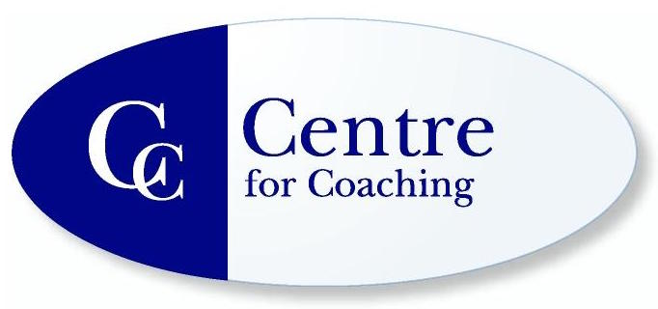
International Academy for Professional Development Ltd
in partnership with the
Centre for Coaching

ILM APPROVED DEVELOPMENT PROGRAMME
APPLICATION FORM
Please complete and return in Word format to admin@iafpd.com

Name (include title): | Date of Birth:
Postal Address (Course Material for Coaching Development Programme will be sent to this address) | Contact Tel:
Occupation: | Email Address (Booking confirmation and Joining instructions inc pre-reading will be issued to this address – check spam/junk folder if not received)
Note: all correspondence will be via email so do not forget to check your spam folder!

Course 1:  Coaching Development Programme | Fee:  £1040 individual  £1295 organisational | Course Date:
Course 2:  Psychological Coaching Development Programme  NB: this course should be taken after course 1 has been completed | Fee:  £1140 individual  £1320 organisational | Course Date:

The Centre and Academy are committed to equal opportunities for all: please complete as appropriate:
Gender □ Male □ Female
Ethnic origin □ White – Irish □ White – British □ White - Other
□ Black – Caribbean □ Black – African □ Black – Other Black Groups
□ Indian □ Pakistani □ Bangladeshi □ Chinese □ Other
Disability □ Non-disabled □ Disabled
Sponsorship □ Funded by organisation □ Part funded by organisation □ Self funded

Please give a brief outline of your work with particular reference to the use of coaching

Qualifications:

Previous training in coaching or related fields Yes / No

Please indicate the extent of your training and the models used (e.g. GROW, CBC, SFP etc).

Please state your reasons for wanting to attend the course(s)

Where did you hear about the Centre’s courses?

Special Requirements:

PAYMENT
Promotional Code (if applicable):

Course fees must be paid by the due date on the invoice that is sent to you at the time of your confirmation of booking email. If your fee has not been paid by this date and despite our best efforts to contact you, your place on the course will be cancelled.

Self Funding
An electronic invoice will be sent to the email address stated above, to enable payment to be made securely with a credit or debit card. We are unable to take payment over the phone.

Receipts will not be issued, please print the electronic invoice and payment receipt for your records.

Your place is not confirmed until your payment is received.

Organisation
If you are paying the organisational fee and require an invoice to be sent to your organisation, please provide the company name and address along with the name and email of the contact. Invoices will be sent in PDF format by email.
Please state Purchase Order numbers if applicable. Payment due within 30 days of invoice.

EMAIL TO:

COMPANY NAME:

ADDRESS:

Continued….

CANCELLATION & TRANSFER POLICY

The contract is cancellable within the standard 14 day cooling off period. If cancelled within this 14 day period, we will offer a full refund.

As our class size normally consists of 15 or less learners we have a cancellation & transfer policy. If you cancel after the 14 day cooling off period the following cancellation fees will apply:

More than 4 weeks before course begins Full Refund
2-4 weeks before course begins 75% of fee
1-2 weeks before course begins 50% of fee
7 days or less before course begins no refund

If you choose to transfer within the 4 week period the following additional fees apply:

More than 4 weeks before course begins no fee
2-4 weeks before course begins 25% of original fee
1-2 weeks before course begins 50% of original fee
7 days or less before course begins Full course fee

The Centre reserves the right to alter or cancel courses. If we cancel a course, workshop or event, delegates will be offered the choice of a 100% refund or a direct transfer to another event run by the Centre and Academy. No liability is accepted for any consequential loss or any other expenses directly or indirectly incurred by any cancellation.

Due to the nature of the workshops, delegates must attend over 90% of any individual course to satisfy attendance requirements if certification is required.

I opt-in to receiving further correspondence relating to other courses,
workshops and conferences that the Centre and Academy offer. YES NO

I have read the Privacy Policy: www.centreforcoaching.info/privacy-policy/

I have read and agree to the above conditions. I confirm that I have read the relevant course details including the section headed General course information which can be found here:
https://www.centreforcoaching.info/about/general-programme-information/

Electronic signature of applicant: Date:

PLEASE RETURN COMPLETED APPLICATION FORM in WORD FORMAT TO:
admin@iafpd.com

WE WILL ACKNOWLEDGE RECEIPT OF YOUR FORM – IF YOU DO NOT HEAR FROM US CHECK YOUR SPAM/JUNK FOLDER OR MAKE FURTHER CONTACT BY PHONE

YOU ARE NOT BOOKED ONTO A TRAINING COURSE UNTIL YOU RECEIVE A BOOKING CONFIRMATION EMAIL FROM US

Courses are held in Central London

July 2019

